COMBINATIONAL CIRCUITS

OBJECTIVE:
- Implementation of Combinational Circuits.

PROCEDURE:
Combination Circuits: The combinational logic circuits are a type of logic circuits containing only logic gates (AND, OR, XOR, NOT, NAND, NOR) and its output only depends on the current input (do not have memory).

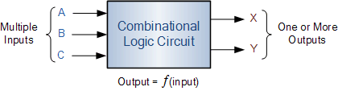

The three main ways of specifying the function of a combinational logic circuit are:
- Boolean algebra: This forms the algebraic expression showing the operation of the logic circuit for each input variable either True or False that result in a logic “1″ output.
- Truth Table: A truth table defines the function of a logic gate by providing a concise list that shows all the output states in tabular form for each possible combination of input variable that the gate could encounter.
- Logic Diagram: This is a graphical representation of a logic circuit that shows the wiring and connections of each individual logic gate, represented by a specific graphical symbol that implements the logic circuit.

EQUIPMENT / REQUIREMENT:
- 7404IC.
- 7408 IC.
- 7432 IC.
- 7400 & 7402 IC
- LED
- 0-5 VOLT DC Power Supply.

COMBINATIONAL LOGIC GATE SCHEMATIC
The circuit in the diagram below uses two-input AND gates to provide a three-input AND gate.

A
B
C

This is one method of producing a three-input AND gate
A
B
C

A truth table drawn for both circuits will show the logic function clearly:

C | B | A | O/P
0 | 0 | 0 | 0
0 | 0 | 1 | 0
0 | 1 | 0 | 0
0 | 1 | 1 | 0
1 | 0 | 0 | 0
1 | 0 | 1 | 0
1 | 1 | 0 | 0
1 | 1 | 1 | 1
Table 5.1

Task#1: Derive the truth table and Boolean expression for the output of the following logic circuits.
P
Q
R

R | Q | P | ___  P.Q | _  R | _______  ___ _  P.Q + R
0 | 0 | 0 | 1 | 1 | 0
0 | 0 | 1 | 1 | 1 | 0
0 | 1 | 0 | 1 | 1 | 0
0 | 1 | 1 | 0 | 1 | 0
1 | 0 | 0 | 1 | 0 | 0
1 | 0 | 1 | 1 | 0 | 0
1 | 1 | 0 | 1 | 0 | 0
1 | 1 | 1 | 0 | 0 | 1

Task#2: Implement circuit for the following equation
Y=AB+C+D+DE
A | B | B’ | C | D | D’ | E | AB’ | (C or D)’ | (D’ and E)’ | Output
0 | 0 | 1 | 0 | 0 | 1 | 0 | 0 | 1 | 1 | 1
0 | 0 | 1 | 0 | 0 | 1 | 1 | 0 | 1 | 0 | 1
0 | 0 | 1 | 0 | 1 | 0 | 0 | 0 | 0 | 1 | 1
0 | 0 | 1 | 0 | 1 | 0 | 1 | 0 | 0 | 1 | 1
0 | 0 | 1 | 1 | 0 | 1 | 0 | 0 | 0 | 1 | 1
0 | 0 | 1 | 1 | 0 | 1 | 1 | 0 | 0 | 0 | 0
0 | 0 | 1 | 1 | 1 | 0 | 0 | 0 | 0 | 1 | 1
0 | 0 | 1 | 1 | 1 | 0 | 1 | 0 | 0 | 1 | 1
0 | 1 | 0 | 0 | 0 | 1 | 0 | 0 | 1 | 1 | 1
0 | 1 | 0 | 0 | 0 | 1 | 1 | 0 | 1 | 0 | 1
0 | 1 | 0 | 0 | 1 | 0 | 0 | 0 | 0 | 1 | 1
0 | 1 | 0 | 0 | 1 | 0 | 1 | 0 | 0 | 1 | 1
0 | 1 | 0 | 1 | 0 | 1 | 0 | 0 | 0 | 1 | 1
0 | 1 | 0 | 1 | 0 | 1 | 1 | 0 | 0 | 0 | 0
0 | 1 | 0 | 1 | 1 | 0 | 0 | 0 | 0 | 1 | 1
0 | 1 | 0 | 1 | 1 | 0 | 1 | 0 | 0 | 1 | 1
1 | 0 | 1 | 0 | 0 | 1 | 0 | 1 | 1 | 1 | 1
1 | 0 | 1 | 0 | 0 | 1 | 1 | 1 | 1 | 0 | 1
1 | 0 | 1 | 0 | 1 | 0 | 0 | 1 | 0 | 1 | 1
1 | 0 | 1 | 0 | 1 | 0 | 1 | 1 | 0 | 1 | 1
1 | 0 | 1 | 1 | 0 | 1 | 0 | 1 | 0 | 1 | 1
1 | 0 | 1 | 1 | 0 | 1 | 1 | 1 | 0 | 0 | 1
1 | 0 | 1 | 1 | 1 | 0 | 0 | 1 | 0 | 1 | 1
1 | 0 | 1 | 1 | 1 | 0 | 1 | 1 | 0 | 1 | 1
1 | 1 | 0 | 0 | 0 | 1 | 0 | 0 | 1 | 1 | 1
1 | 1 | 0 | 0 | 0 | 1 | 1 | 0 | 1 | 0 | 1
1 | 1 | 0 | 0 | 1 | 0 | 0 | 0 | 0 | 1 | 1
1 | 1 | 0 | 0 | 1 | 0 | 1 | 0 | 0 | 1 | 1
1 | 1 | 0 | 1 | 0 | 1 | 0 | 0 | 0 | 1 | 1
1 | 1 | 0 | 1 | 0 | 1 | 1 | 0 | 0 | 0 | 0
1 | 1 | 0 | 1 | 1 | 0 | 0 | 0 | 0 | 1 | 1
1 | 1 | 0 | 1 | 1 | 0 | 1 | 0 | 0 | 1 | 1
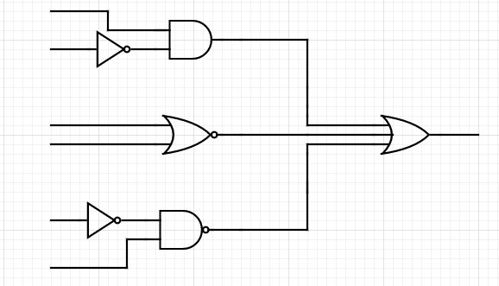
A AB’
B
C (C or D)’ AB’ + (C or D)’ + (D’ and E)’
D

D
E (D’ and E)’
CONCLUSION:
A Combinational Circuit consist of logic gates whose outputs at any instant of time are determined directly from the present combination of inputs without regard to previous input.

